**CARWEBSITE**

(WEBSITE)

By

MOHAMED ABDFITAH MUUMED

BIT2114 PROJECT (BSSE/BSCS/BIT)

FACULTY OF SCIENCE AND TECHNOLOGY

**INTERNATIONAL UNIVERSITY OF EAST AFRICA**

A Technical Design Document submitted to the IUEA

Supervisor

Ssebanyiiga Magezi Francis

Faculty of Science and Technology

francis.ssebanyiiga@iuea.ac.ug, +256-779250096.

**ACKNOWLEGEDEMENT**

I extend my gratitude to the faculty and administration of IUEA for providing the opportunity to develop this project, which has enhanced my technical and collaborative skills. Special thanks to my supervisor, Mr. Magezi Francis, for his invaluable guidance and expertise throughout this endeavor

**IUEA-PROJECT SYNOPSIS**

The **Car Website** is designed to serve as a comprehensive platform for showcasing new and used cars, facilitating online transactions, and providing detailed information about vehicles (e.g., specifications, pricing, and dealership locations). Key features include:

* **Car Listings**: Display cars with filters for brand, price, and model year.
* **Virtual Showroom**: High-quality images and 360° views of vehicles.
* **Online Booking**: Users can schedule test drives or request quotes.
* **Dealer Integration**: Connect users with certified dealers.
* **Blog Section**: Articles on car maintenance, reviews, and industry news.

The website emphasizes user convenience, security, and modern design to align with Uganda’s growing digital automotive market.

**PROJECT ANALYSIS**

The Car Website addresses the need for a centralized platform to streamline car purchases and research in Uganda. It solves challenges such as:

* Fragmented information across dealerships.
* Limited access to vehicle details and comparisons.
* Time-consuming offline processes for test drives and purchases.

# BENEFITS OF THE PROJECT

1. **Centralized Information**: Users access car specifications, prices, and dealer contacts in one place.
2. **Time Efficiency**: Reduces physical visits to dealerships through online bookings.
3. **Cost Savings**: Free advertising for dealers and competitive pricing for buyers.
4. **Transparency**: Verified listings and user reviews ensure trust.
5. **Technological Advancement**: Encourages Uganda’s shift to digital solutions in th

**PROJECT DESIGN TREE**

**HOME**

**ABOUT US**

**SERVICES**

**TEAM**

**CONTACT**

**FAQ**

**CAR MODLES**

Switch to xperia

& an

**IUEA-PROJECT SCREENSHOTS**

1. **UEA-PROJECT SCREENSHOTS**

*(Replace with your actual screenshots and descriptions)*

links

**Car Listings Page**: Filterable grid of cars with prices and specs.

.

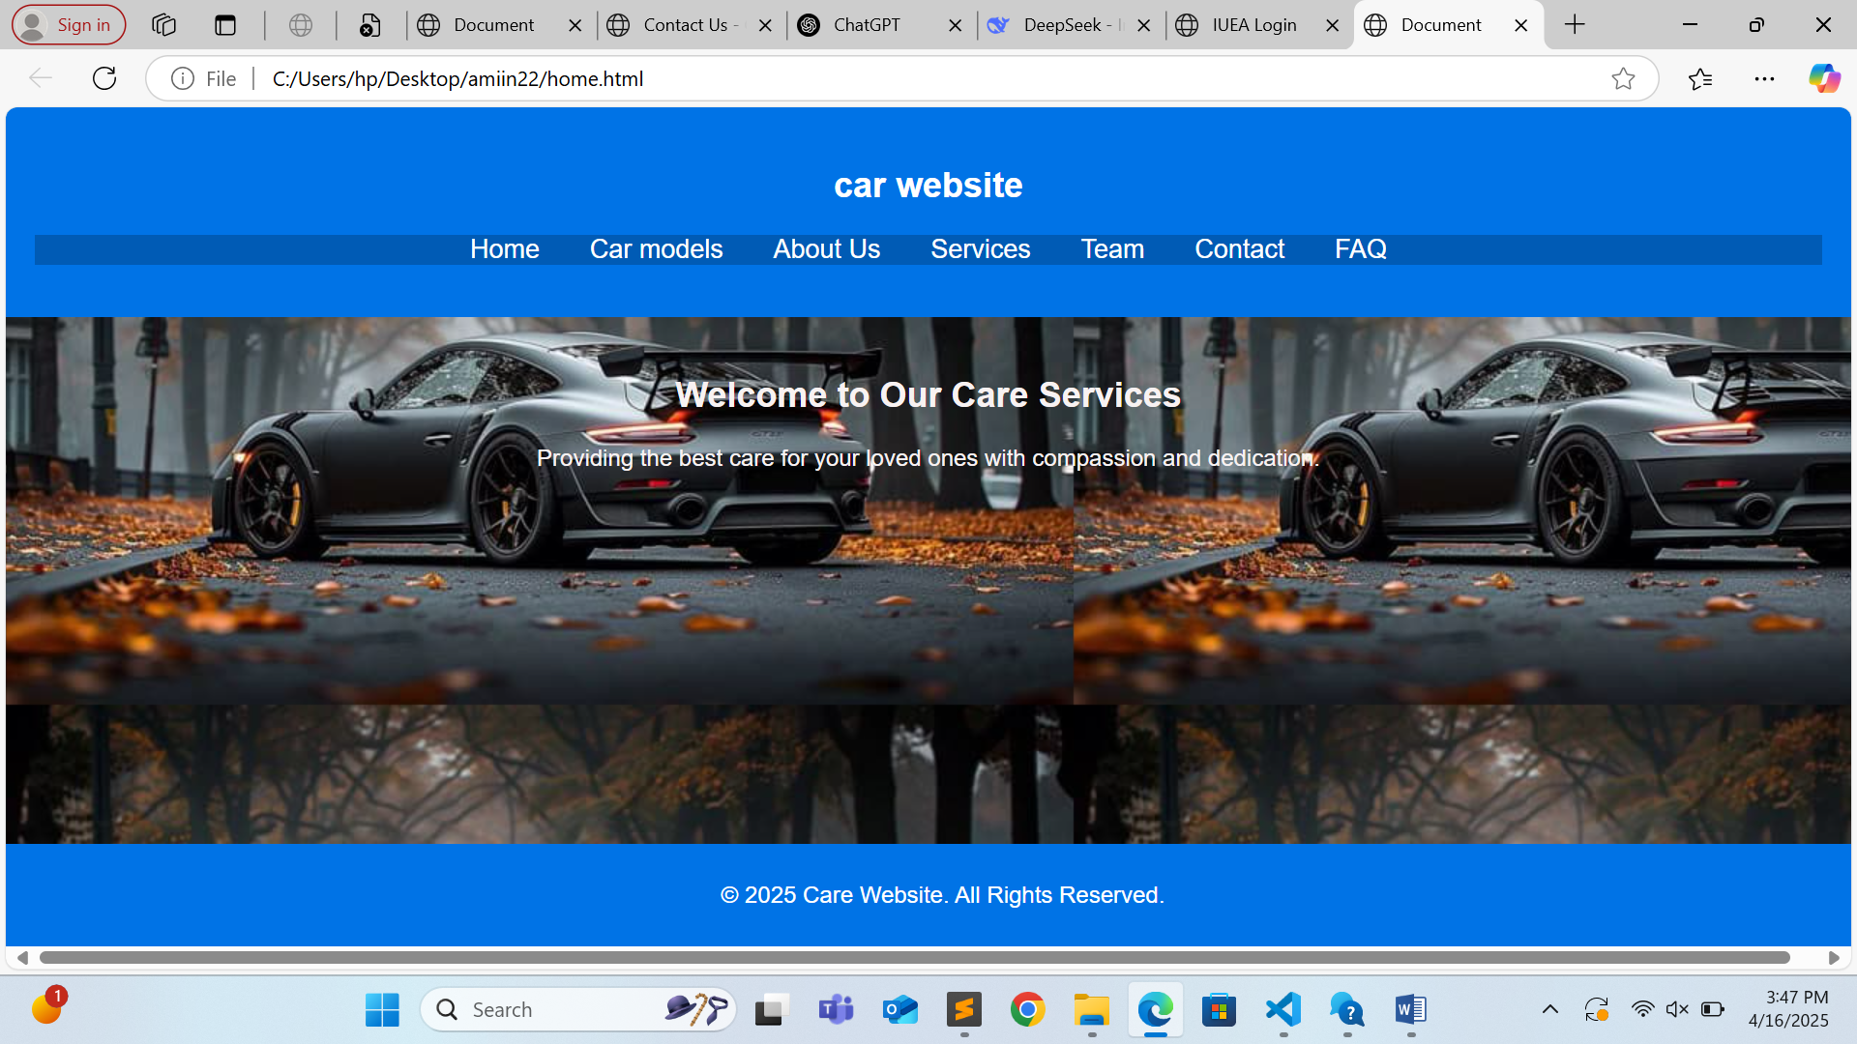

Car Listings Page: Filterable grid of cars with prices and specs.

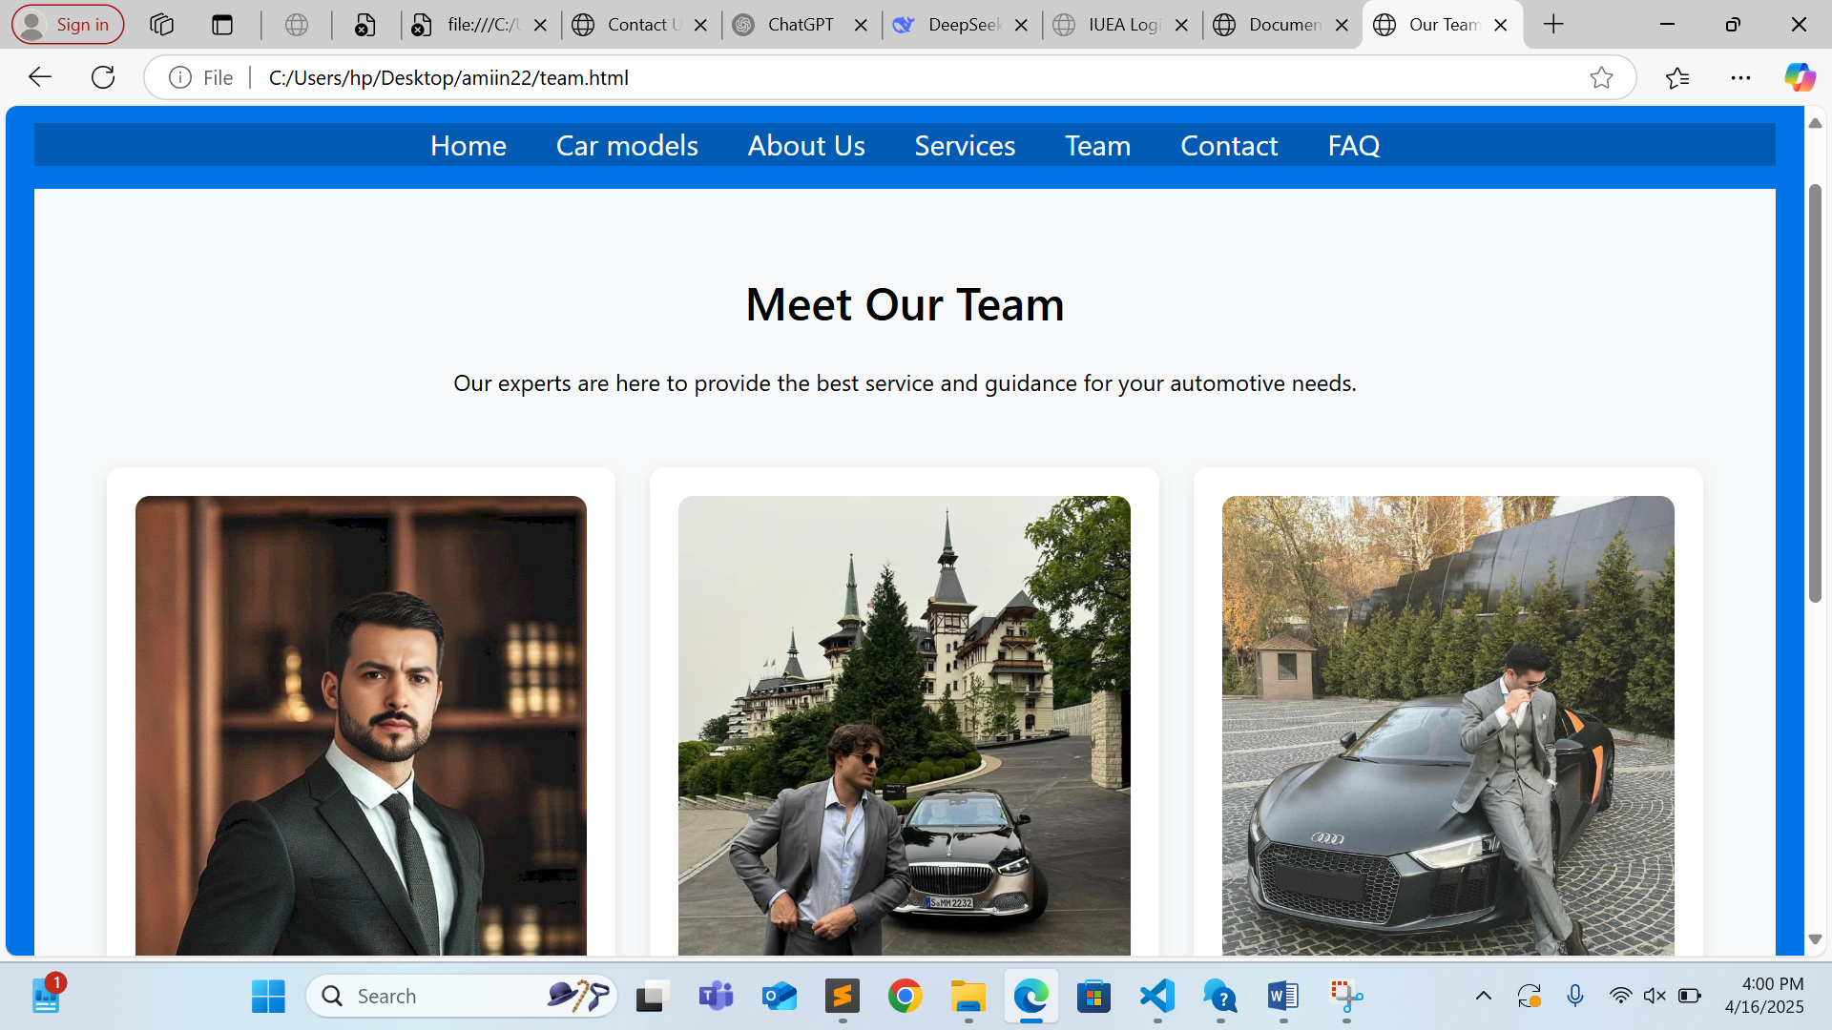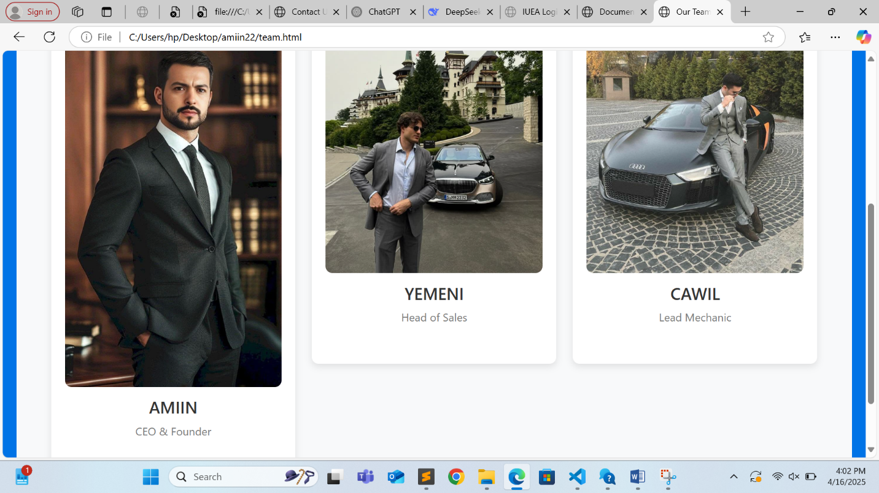

**Virtual Showroom**: Interactive 360° view of a selected car.

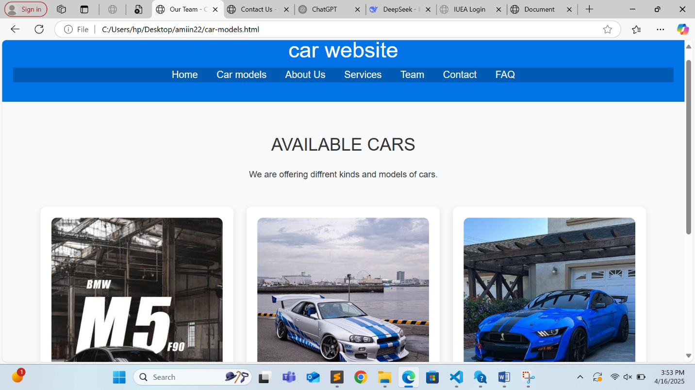

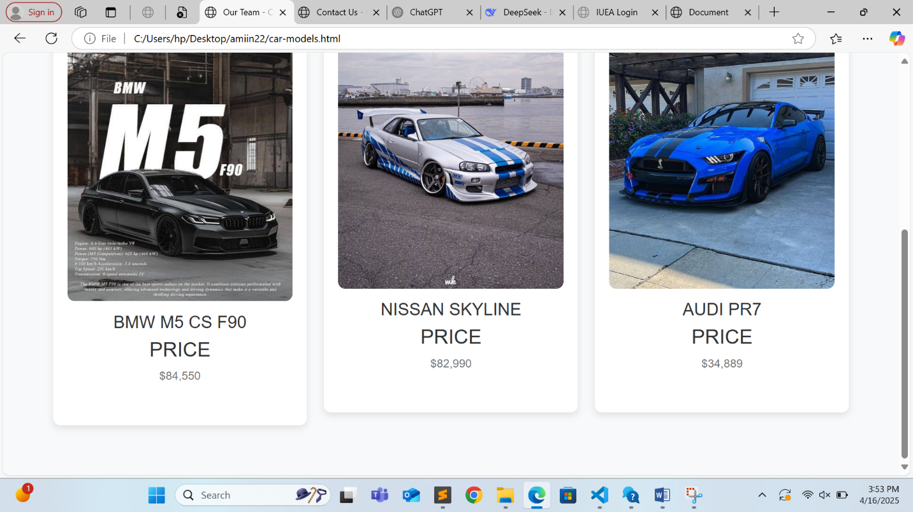

**Dealer Map**: Locations of certified dealers with contact details

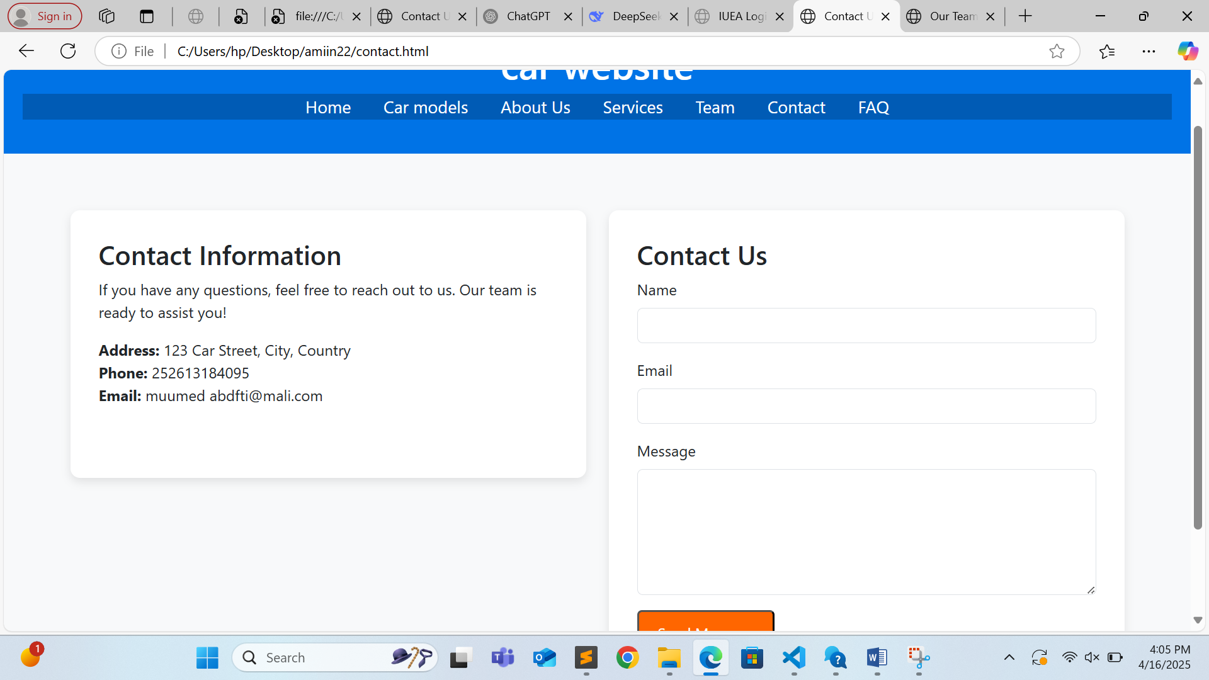

**USER’S GUIDE**

1. **Navigation**: Use the top menu to explore car listings, virtual showrooms, or blogs.
2. **Search**: Filter cars by brand, price range, or model year.
3. **Booking**: Click “Schedule Test Drive” on a car’s details page.
4. **Dealer Contact**: Click “Contact Dealer” for instant inquiries.

**DEVELOPER’S GUIDE**

* **Frontend**: HTML5, CSS3, JavaScript (React.js for interactivity).
* **Backend**: Node.js, MongoDB (for user data and car listings).
* **Design Tools**: Figma (prototyping), Adobe Photoshop (image editing).
* **Deployment**: Hosted on AWS with SSL encryption for secu

**TASK MANAGER FOR THE IUEA-PROJECT**

|  |  |
| --- | --- |
| TASK ACCOMPLISHED | DATE |
| Designed website layout in Figma | 15/03/2025 |
| Developed frontend pages | 20/03/2025 |
| Integrated backend APIs | 25/03/2025 |
| Added car listings database | 30/03/2025 |
| Tested and deployed the website | 05/04/2025 |
|  |  |

* **CRITICAL ANALYSIS & IMPROVEMENTS**
* **Strengths**: User-friendly interface, robust search filters, secure payment gateway.
* **Limitations**: Limited dealer network outside Kampala.
* **Future Work**: Add a mobile app version and AI-based car recommendations.